=======================================
aiToJoe chats
=======================================
=========================
============
========
====
==
=

Summary of Key Points:
- Microsoft 365 Agents SDK is not the same as Copilot Studio environments.
- Agents SDK = pro-code development framework.
- Copilot Studio environment URL = hosted runtime/container for agents.
- They integrate via skills.

Full Response:
Short answer: No — Microsoft 365 Agents SDK and a Copilot Studio environment URL are not the same thing.

The Agents SDK is a developer framework used to build agents in code (C#, JavaScript, Python). These agents are hosted externally (typically in Azure) and can be exposed as skills.

The Copilot Studio URL (copilotstudio.microsoft.com/environments/...) points to a specific Power Platform environment where agents are created, managed, and run using a low-code interface.

The connection between the two is through “skills”. An agent built using the Microsoft 365 Agents SDK can be exposed as a skill and then registered inside a Copilot Studio agent, allowing the Copilot Studio agent to call it during conversations.

So:
- Agents SDK = how you build advanced/custom agents
- Copilot Studio environment = where agents are hosted and orchestrated
- Skills = integration bridge between them

=======================================
=========================
============
========
====
==
=
opp SDK .. like a ‘software development kit’ / library stuff
====
==
=

Summary of Key Points:
- Copilot Studio is NOT an SDK; it is a low-code/no-code platform.
- Microsoft 365 Agents SDK is a separate pro-code framework.
- Agents SDK is newer (replacing Bot Framework), not an old name for Copilot Studio.
- The confusion comes from naming convergence around “agents”.

User Question:
but as per pic, it looks like copilotstudio is a type of sdk for agents
maybe 'Microsoft 365 Agents SDK' is an old name or older tool replaced by pic? Think you said that in past

Full Response:
Short answer: No — Copilot Studio is not a type of SDK, and Microsoft 365 Agents SDK is not an old name for it.

What your screenshot shows is the Copilot Studio UI. This is a low-code/no-code platform built on the Power Platform where agents are created, stored, and managed inside environments. It looks “developer-like” because it deals with agents, but it is not a software development kit.

The Microsoft 365 Agents SDK is a separate, newer pro-code framework used to build agents in code (C#, JavaScript, Python). These agents are typically hosted in Azure or another environment and can expose functionality.

The key relationship:
- Copilot Studio = visual builder and orchestrator
- Agents SDK = code-based agent development framework
- Skills = integration mechanism between them

Important clarification:
- Copilot Studio was formerly Power Virtual Agents (renamed, not replaced)
- Microsoft 365 Agents SDK is the evolution/replacement of Bot Framework

So:
- Agents SDK did NOT replace Copilot Studio
- Copilot Studio did NOT become the SDK
- They are parallel tools in the same ecosystem

Why it feels confusing:
Microsoft unified everything under the “agent” concept, so both tools now use similar terminology and appear in the same documentation flows.

=======================================
=========================
============
========
====
==
=

Summary of Key Points:
- Copilot Studio can do MANY things but not everything the Agents SDK can.
- Copilot Studio excels at orchestration, connectors, and rapid agent creation.
- Agents SDK enables deeper control, custom logic, and complex architectures.
- They overlap but are not equivalent in capability.

User Question:
if this is true:
Copilot Studio = Power Apps for agents, Agents SDK = Visual Studio for agents
— can someone using only Copilot Studio do most everything someone using the Agents SDK can?

Full Response:
Short answer: They can do a lot—but NOT most everything.

More precise answer (important at your level):
Copilot Studio covers roughly 60–80% of common enterprise agent scenarios, especially:
- Q&A agents
- Workflow automation
- Connector-based integrations
- Light orchestration and responses

Where Copilot Studio is strong:
- Rapid development (minutes/hours)
- 1000+ connectors (Power Platform)
- Built-in orchestration and grounding
- Easy deployment within Microsoft environments

Where it falls short vs Agents SDK:
- Deep custom logic and control flow
- Multi-agent coordination logic you fully control
- Custom memory/state management
- Complex tool chaining and reasoning pipelines
- Custom hosting/runtime control
- Integration with non-standard systems at low level

Where Agents SDK is required:
- Advanced enterprise architectures
- Highly customised AI behaviour
- Performance-sensitive or scaled systems
- Complex orchestration beyond what flows/skills allow

Better mental model:
- Copilot Studio = 80% solution, fast
- Agents SDK = 100% control, slower but more powerful

Critical insight (this is the real answer):
Most organizations will use BOTH:
- Copilot Studio as the front-end/orchestrator
- Agents SDK for specialised capabilities behind the scenes

Self-critical note:
It would be misleading to say Copilot Studio can replace SDK usage. It can replace it for simple/medium scenarios, but not for advanced engineering cases.

=======================================
=========================
============
========
====
==
=

Summary of Key Points:
- Your VS Code screenshots point to Microsoft 365 Agents Toolkit and MCP tooling, not Copilot Studio.
- m365agents.local.yml is a hallmark of an Agents Toolkit project.
- mcp.json is MCP configuration used by GitHub Copilot/VS Code tooling and can coexist with Agents Toolkit.
- This does not automatically mean the project is an Agents SDK custom-engine agent;
it may instead be a declarative agent, connector, plugin, or Teams/M365 app scaffolded by the toolkit.

User Question:
..as per pics, then how does this vscode fit in to the picture. This folder lets one play with mcp.json,
lets one build typescript ms sample projects (ie: github issues connector on ms learn)
.. even has a tab called m365agents.local.yml....
are these pics MS Agents SDK? I know it is not copilotstudio.com

Full Response:
Short answer: the screenshots are most likely showing the Microsoft 365 Agents Toolkit in VS Code, plus MCP tooling.
They are related to the Microsoft 365 Agents ecosystem, but they are not automatically the same thing as “an Agents SDK project”.

What the screenshots suggest:
1) The file m365agents.local.yml strongly indicates a Microsoft 365 Agents Toolkit project.
Microsoft documents m365agents.yml as the main Agents Toolkit project file and m365agents.local.yml as the local override used for local execution/debugging.
2) The mcp.json file indicates Model Context Protocol server configuration in VS Code / GitHub Copilot Agent mode.
Microsoft also documents using .vscode/mcp.json together with the Microsoft 365 Agents Toolkit MCP Server and MCP-based Copilot extensibility workflows.
3) Therefore, your VS Code setup fits on the “developer/pro-code side” of the picture, not the Copilot Studio web UI side.

Important nuance:
- Agents Toolkit is a developer toolchain / extension / deployment helper.
- Agents SDK is the runtime/framework you code against when building custom engine agents.
- An Agents Toolkit project can scaffold or manage several things: Teams apps, declarative agents, plugins, connectors, and also some Agents SDK-based projects.

So are your screenshots “MS Agents SDK”?
- Maybe partly, but not necessarily.
- They are definitely in the Microsoft 365 Agents Toolkit world.
- They are only an Agents SDK project if the sample/template itself is built on the Microsoft 365 Agents SDK runtime.

For your specific GitHub Issues Connector example:
Microsoft’s sample describes a broader solution that combines a Graph connector, webhook/Azure Function, declarative agent, and API plugin.
That kind of project can be created and managed through toolkit files like m365agents.local.yml without being a pure custom-engine Agents SDK bot.

Best mental model:
- Copilot Studio = browser UI builder/orchestrator
- Agents Toolkit in VS Code = developer scaffolding/provisioning/debugging/deployment layer
- Agents SDK = code framework/runtime for custom agents
- MCP = a protocol/tooling bridge that VS Code/GitHub Copilot can use to work with agent/dev tools and MCP-exposed services

Bottom line:
Your screenshots are best described as:
“Microsoft 365 Agents Toolkit + MCP tooling in VS Code”.
That sits beside Copilot Studio, and can support Agents SDK projects, but is not identical to Copilot Studio and not automatically identical to the Agents SDK itself.

References:
- Microsoft Learn: Microsoft 365 Agents Toolkit
- Microsoft Learn: Microsoft 365 Agents SDK documentation
- Microsoft Learn: Build plugins from an MCP server for Microsoft 365 Copilot
- Microsoft Learn: GitHub Issue Manager sample agent

=======================================
=========================
============
========
====
==
=

User Question:
so the re: Microsoft 365 Agents SDK = code framework/runtime for building custom agents this is like, in the .net world,
the .net framework that ie: generates / compiles one's code to a just in time MSIL
ie: Microsoft 365 Agents SDK is not somethine I open like visual studio for .net?

Full Response:
Great question — and you’re very close, but the analogy needs one small correction.

Short answer:
Yes, Microsoft 365 Agents SDK is closer to a framework/runtime/library layer than to an IDE. No, it is not something you “open” like Visual Studio.

A tighter .NET analogy:
- Visual Studio / VS Code = the IDE or editor you open
- Agents Toolkit = the project scaffolding / provisioning / debugging / deployment helper
- Microsoft 365 Agents SDK = the framework/libraries you reference in code
- Node.js runtime or .NET runtime = the underlying execution runtime that actually runs your code

So the SDK is not the thing that compiles your project in the way the .NET compiler turns C# into IL/MSIL. It does not play the role of the C# compiler, JIT, or CLR.

A more accurate comparison would be:
- Agents SDK is like ASP.NET Core plus some AI/agent orchestration libraries
- It gives you programming abstractions, agent patterns, tool-calling support, conversation handling, and orchestration capabilities
- But it still runs inside a normal language/runtime environment such as JavaScript on Node.js, or .NET if you are using the .NET flavor

So if you are thinking in .NET terms, the right mental model is:
“It is a developer library/framework used inside my project, not the development environment itself.”

That is why in your screenshots you open VS Code, you see files like m365agents.local.yml, package.json, TypeScript files, and maybe mcp.json.
Those are project files and tooling configuration. If the project uses the Microsoft 365 Agents SDK,
then the SDK is one of the code dependencies inside that project — not the app you opened.

Where your original analogy was right:
- It is on the framework/runtime side, not the GUI tooling side

Where your original analogy was off:
- It does not itself generate MSIL or behave like the .NET compilation pipeline
- It is not an IDE

Best one-line takeaway:
Microsoft 365 Agents SDK is something you code against, not something you launch.

If you want an even tighter enterprise-dev analogy:
- Copilot Studio = Power Apps for agents
- Agents Toolkit = Teams Toolkit / scaffolding + deployment helper for agent projects
- Agents SDK = ASP.NET Core style framework layer for building custom agent logic
- MCP = protocol/config bridge for tools and agent integrations

That is the cleanest way to place it.

References:
- No external sources used

===================================

===================================

===================================

===================================

===================================
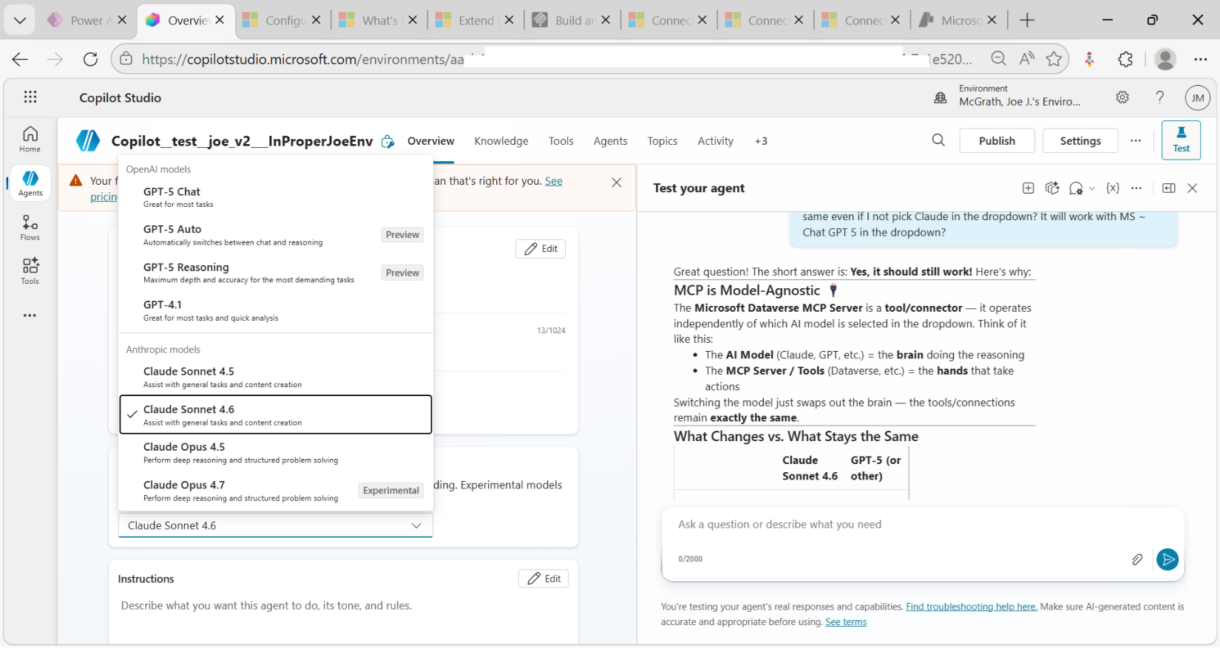

Hello, I'm Copilot__test__joe_v2___InProperJoeEnv. How can I help?

Sent at May 14 at 11:49 AM
11 minutes ago
Bot said: Hello, I'm Copilot__test__joe_v2___InProperJoeEnv. How can I help? Message is interactive. Click to interact.
You said:
do you need claude sonnect model as basis? or can you be switched to gpt ? .. maybe you need claude since that the company I think that did the mcp protocol that dataverse uses for you?

Bot said:
Great questions! Let me clarify a few things:
My Underlying Model
- I'm not able to disclose details about the specific AI model powering me. What I can tell you is that I'm configured as an AI Agent in this environment, and my focus is on helping you work with Microsoft Dataverse and related tools.
About MCP (Model Context Protocol)
- The MCP (Model Context Protocol) that Dataverse uses was actually developed by Anthropic (the company behind Claude), but it has since become an open standard adopted broadly across the AI industry.
- Both OpenAI (GPT) and Anthropic (Claude) — as well as other AI providers — support MCP. So the protocol itself is model-agnostic.
Can I Be Switched?
- Whether the underlying model can be changed depends on how this agent was configured and deployed by your organization/administrator. That's typically a setup decision made at the platform or environment level, not something I can change myself.

Is there anything else you'd like to know, or can I help you with your Dataverse data today? 😊

Sent at May 14 at 11:51 AM
9 minutes ago

You said: here is a pic of the overview tab.. there is a dropdown where I can change it. Can it be changed? 1 attachment.
Bot said:
Great screenshot! That answers both questions clearly. Here's what I can see:
Yes — It Can Be Changed! ✅
The "Select your agent's model" section on the Overview tab in Copilot Studio shows a dropdown currently set to:
Claude Sonnet 4.6
So that also confirms — yes, I am running on Claude Sonnet 4.6! 😄

How to Change It
- Go to Copilot Studio → your agent → Overview tab
- Find the "Select your agent's model" section
- Click the dropdown (currently showing Claude Sonnet 4.6)
- Select your preferred model (e.g., a GPT-based model from OpenAI, if available in the list)
- Save/Publish the changes

A Few Things to Note
- The available models in the dropdown depend on what Microsoft has made available in Copilot Studio at any given time.
- The note on screen says: "Experimental models are subject to [preview terms](​https://preview​ terms)" — so some options may still be in preview.
- ⚠️ Your free trial expires in 1 day, so you may want to contact your admin about the plan before making changes.
Would you like help with anything else? 😊

Sent at May 14 at 11:55 AM
5 minutes ago

You said:
so my agent that has the 'Microsoft Dataverse MCP Server' will still be the same even if I not pick Claude in the dropdown? It will work with MS ~ Chat GPT 5 in the dropdown?
Bot said:
Great question! The short answer is: Yes, it should still work! Here's why:

MCP is Model-Agnostic 🔌
The Microsoft Dataverse MCP Server is a tool/connector — it operates independently of which AI model is selected in the dropdown. Think of it like this:
- The AI Model (Claude, GPT, etc.) = the brain doing the reasoning
- The MCP Server / Tools (Dataverse, etc.) = the hands that take actions
Switching the model just swaps out the brain — the tools/connections remain exactly the same.

What Changes vs. What Stays the Same
 | Claude Sonnet 4.6 | GPT-5 (or other)
Dataverse MCP Server connection | ✅ Same | ✅ Same
Tools configured | ✅ Same | ✅ Same
Topics & Instructions | ✅ Same | ✅ Same
Reasoning/response style | 🔄 May differ | 🔄 May differ
Performance on complex queries | 🔄 May differ | 🔄 May differ

One Thing to Keep in Mind ⚠️
- Different models may handle tool calling and reasoning slightly differently, so the quality or accuracy of responses could vary — but the MCP connection itself won't break.
- It's worth testing after switching to make sure the agent behaves as expected with your Dataverse data.

So go ahead and try GPT-5 if it's available in the dropdown — your Dataverse MCP Server tools will carry right over! 🚀

Sent at May 14 at 11:58 AM
A minute ago

